Git Lab 1 – Mikey Holmes

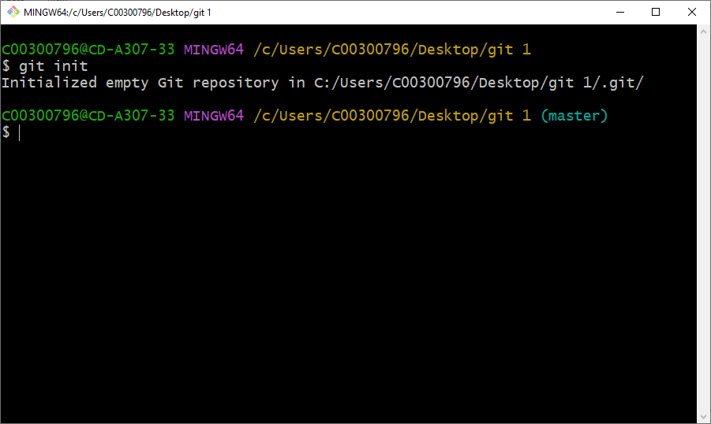

git init - This initialises and creates a git repository only on that pc in the local file.

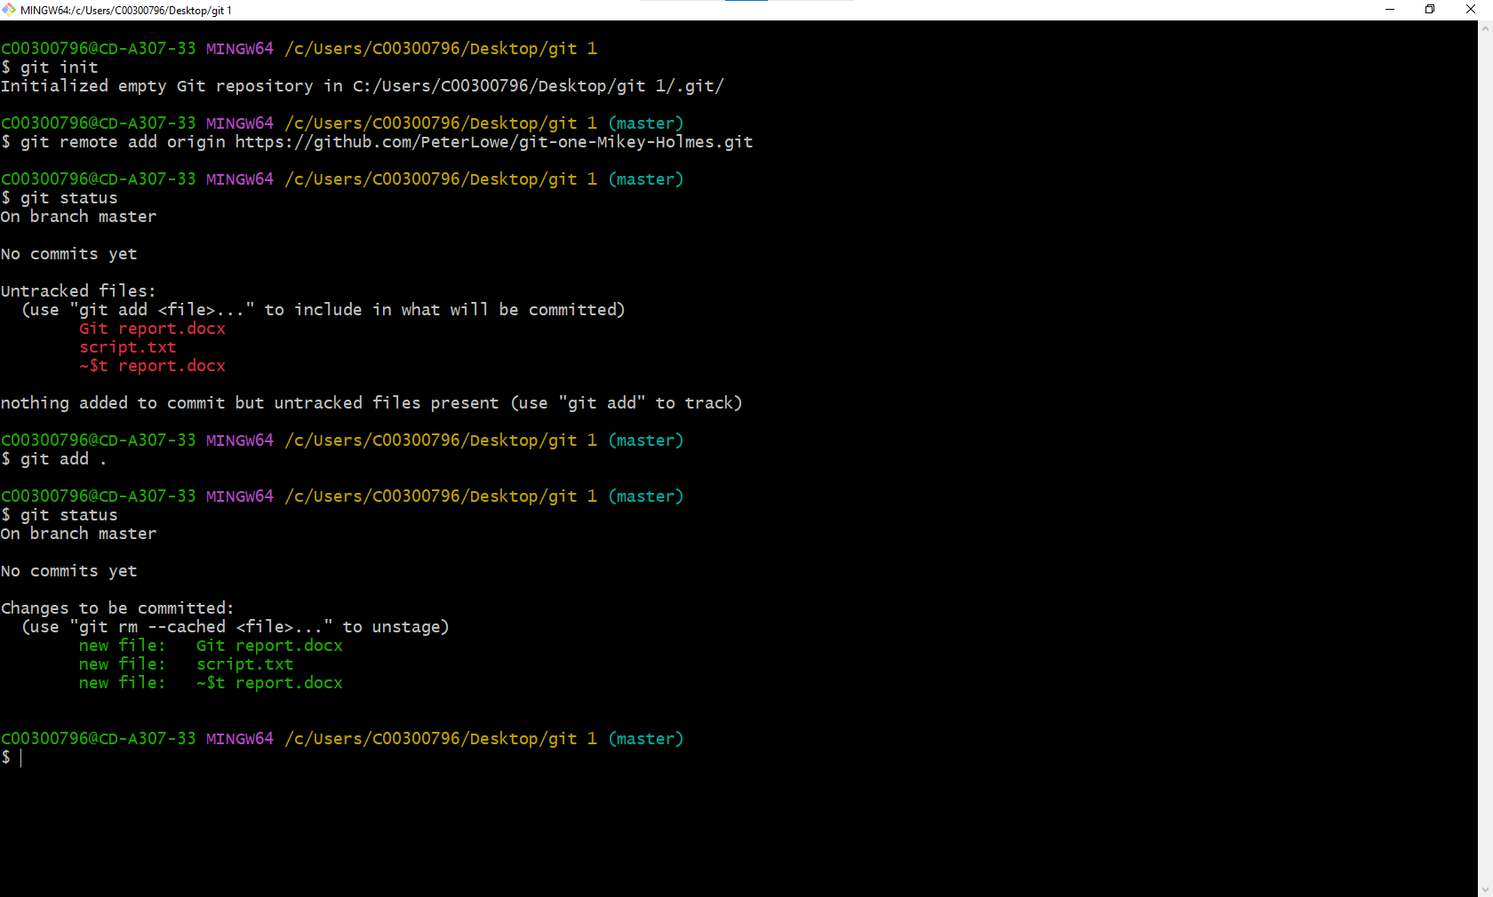

git add – added the files in the folder to the repository

git status- checked to see if the files in the folder were committed

git remote- adding the git remote repository so my git file and changed will be uploaded for review

git commit – committing the files to the remote repository.

git push- pushing the default branch main